**Урок 6. Змейка**

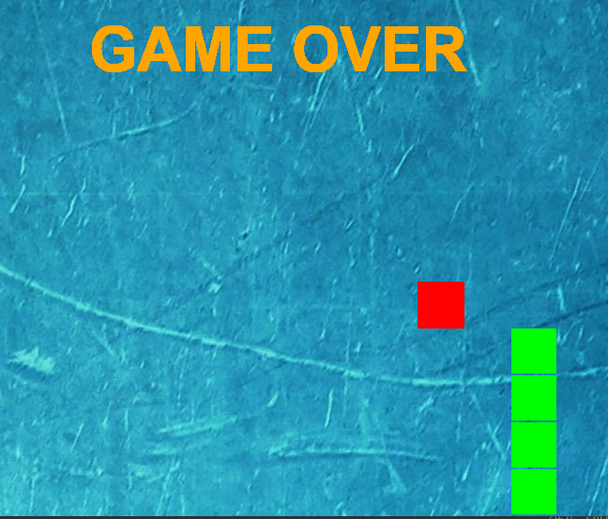

from random import randrange

import sys, pygame

pygame.init()

W_H = 800

SIZE = 50

FPS = 5

S = pygame.display.set_mode((W_H, W_H))

pygame.display.set_caption('Змейка')

clock = pygame.time.Clock()

x, y = 0, 0

dx, dy = 0, 0

SNAKE = [(x, y)]

l = 1

APPLE = randrange(0, 800, 50), randrange(0, 800, 50)

GAME_OVER = False

font_score = pygame.font.SysFont('Arial', 26, bold=True)

font_end = pygame.font.SysFont('Arial', 66, bold=True)

def close_game():

for event in pygame.event.get():

if event.type == pygame.QUIT:

exit()

img = pygame.image.load('1.jpg').convert()

while not GAME_OVER:

S.blit(img, (0, 0)) # S.fill('black')

for i, j in SNAKE:

pygame.draw.rect(S, 'green', (i, j, 48, 48))

render_score = font_score.render(f'ОЧКИ: {l}', 1, 'orange')

S.blit(render_score, (5, 5))

pygame.draw.rect(S, 'red', (*APPLE, 50, 50))

x += dx

y += dy

SNAKE.append((x, y))

SNAKE = SNAKE[-l:]

if SNAKE[-1] == APPLE:

APPLE = randrange(0, 800, 50), randrange(0, 800, 50)

l += 1

FPS += 1

if x < 0 or x > W_H or y < 0 or y > W_H or len(SNAKE) != len(set(SNAKE)):

while True:

render_end = font_end.render('GAME OVER', 1, pygame.Color('orange'))

S.blit(render_end, (W_H // 2 - 200, W_H // 3))

pygame.display.flip()

close_game()

pygame.display.flip()

clock.tick(FPS)

close_game()

keys = pygame.key.get_pressed()

if keys[pygame.K_LEFT]:

dx, dy = -50, 0

if keys[pygame.K_RIGHT]:

dx, dy = 50, 0

if keys[pygame.K_UP]:

dx, dy = 0, -50

if keys[pygame.K_DOWN]:

dx, dy = 0, 50